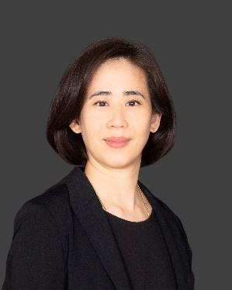 | Carol Pang  Associate  Crawford & Acharya pllc  T: +1 (919) 452-4431 (US) |  Carol@crawfordacharya.com  75 Arlington Street | Suite 500 | Boston, MA 02116

Overview
Carol Pang is an experienced compliance and investigations attorney with an international and diverse perspective. Primarily raised and educated in Taiwan, she is fully bilingual in Mandarin Chinese and English, with law degrees and/or legal qualifications from Taiwan, Hong Kong and the United States. In addition to her significant compliance and investigations experience, she is also a well-rounded legal professional with prior corporate experience at Davis Polk in New York City.

As a senior associate at Ropes & Gray LLP in Hong Kong, she conducted cross-border investigations, risk assessments and compliance reviews for multinational clients in the life sciences sector and conducted due diligence for private equity clients, primarily related to anti-corruption (the Foreign Corrupt Practices Act and other local laws) in China and Asia. Earlier in her career, she was a corporate lawyer with experience in securities and private funds transactions.

Experience

- Conducted investigations, risk assessments and compliance reviews relating to the Foreign Corrupt Practices Act (“FCPA”) and other anti-corruption laws on behalf of multinational companies, with a focus on the life sciences industry in China.
- Presented readout decks, memoranda, and remediation plans to senior management.
- Conducted anti-corruption, anti-money laundering, and sanctions due diligence on behalf of leading private equity firms regarding proposed investments in Asia, including China and India.
- Drafted, negotiated, and reviewed compliance representations and warranties in share purchase agreements and shareholder agreements.
- Reviewed and assisted with risk-management policies and programs related to third-party management, anti-money laundering and anti-corruption for portfolio companies of leading private equity firms.
- Drafted and delivered company-specific presentations on anti-corruption compliance for employees and conducted third-party trainings.
- Conducted an internal investigation on accounting fraud allegations concerning fictitious sales and improper revenue recognition with respect to a U.S.-listed Chinese company.
- Represented major investment banks in connection with equity, interest rate and currency-linked registered structured notes offerings.
- Drafted plain English disclosure language suitable for retail investors regarding complex structures, risk factors and methodologies for proprietary indices related to structured note offerings.
- Provided advice and prepared memoranda regarding legal issues under securities laws, self-regulatory industry regulations and SEC letters/guidance.
- Drafted, negotiated, and reviewed private fund transaction documents, including private placement memorandums, subscription agreements, limited partnership agreements and side letters.

Credentials

Education
- Juris Doctor, Yale Law School (2010); Journal of Regulation, Editor
- Master of Laws, National Taiwan University (2007)
- Bachelor of Laws, National Taiwan University (2004)

Admissions
- New York (2011)
- Taiwan (2004) (Inactive)
- Hong Kong (2018) (Inactive)

